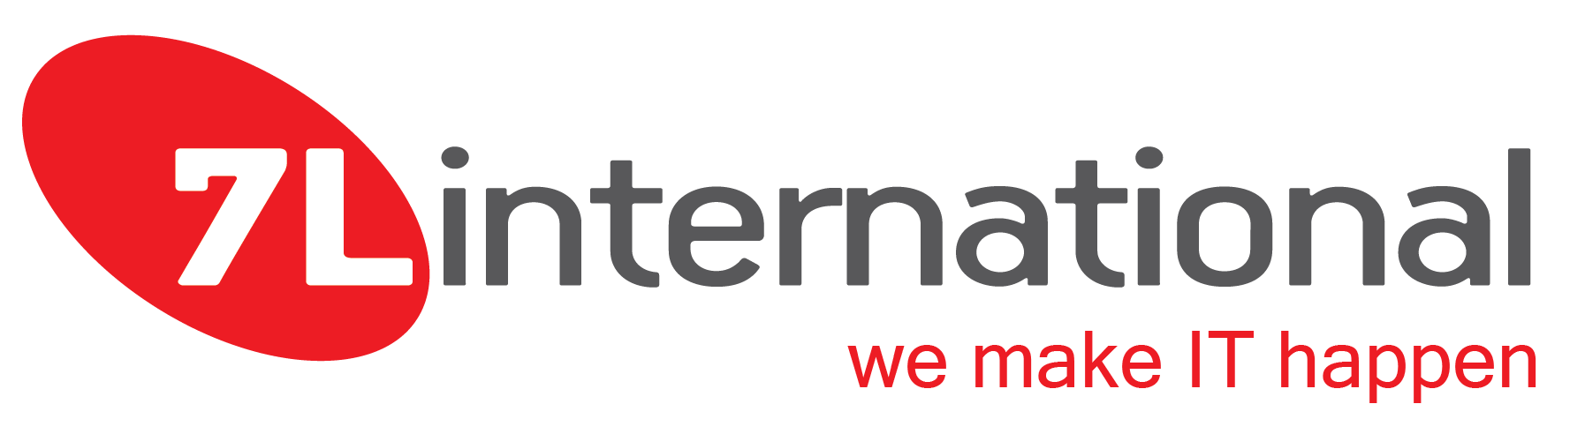

Software QA Engineer - Internship
(Marousi, Attiki)

7L International is a high-performance provider of innovative technological solutions, using its secure custom software and premium infrastructures in global and challenging projects to create a seamless client experience.

We are a team of passionate developers that our extensive expertise and broad experience in custom software development allows us to provide high-quality customized software solutions to any technological challenge.

We are looking for a self-motivated student with enthusiasm and ability to develop technical skills and discover his/her technical expertise career path.

Your responsibilities will include:
- Help design and execute automation scripts using open source tools.
- Participate in development and application of testing processes for new and existing services based on client requirements.
- Documentation and record keeping.
- Working closely with the QA manager for automation development tasks.
- Partner with high skilled developers.
- Sharing learning and innovations with your team.

Knowledge & Skills:
- Understanding at least one of the following tools: (Testrail, TestProject, Selenium, Cucumber, Sonarqube, Jira Zephyr).
- Basic knowledge of version control tools like Git will be appreciated.
- Familiarity with Linux and open source technologies is also a plus.
- Passion for software QA engineering and a keen interest in personal development.
- Energy, initiative, and a positive attitude.
- Teamwork spirit and strong communication skills.

We Offer:

- Fully remote options.
- Access to books, online courses and relevant educational resources.
- Being part of a workplace that offers continuous learning and development and incredible opportunities to upgrade your career.

Visit our site www.7linternational.com to learn more about our company.

If you are ready to practice in a dynamic environment with prospects for development please send a direct mail to internships@7linternational.com with your CV! We’re looking forward to meeting you!

