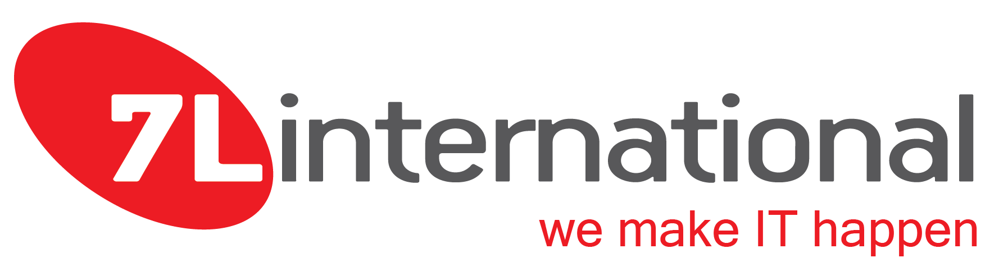

Frontend Software Engineer- Internship
(Marousi, Attiki)

7L International is a high-performance provider of innovative technological solutions, using its secure custom software and premium infrastructures in global and challenging projects to create a seamless client experience.

We are a team of passionate developers that our extensive expertise and broad experience in custom software development allows us to provide high-quality customized software solutions to any technological challenge.

We are looking for a self-motivated student with enthusiasm and ability to develop technical skills and discover his/her technical expertise career path.

Your responsibilities will include:

- Assist in Website, Portal and software application designing, building, or maintaining.
- Conferring with teams to resolve conflicts, prioritize needs, develop content criteria, or choose solutions.
- Maintaining an understanding of the latest Web applications and programming practices through education, study, and participation in conferences, workshops, and groups.
- Identifying problems uncovered by customer feedback and testing, and correcting or referring problems to appropriate personnel for correction.
- Evaluating code to ensure it meets industry standards, is valid, is properly structured, and is compatible with browsers, devices, or operating systems.
- Evaluating code in order to meet security standards.
- Partner with highly skilled developers.
- Assist to track down and resolve technical issues.
- Help to identify and document trends to proactively prevent future problems.
- Sharing learning and innovations with day-to-day tasks.

Knowledge & Skills:

- Knowledge and experience in programming applications.
- Knowledge in JavaScript, HTML, CSS, PHP, MySQL, Git.
- Knowledge of programming language and technical terminology.
- Able to develop ideas and processes and clearly express them.
- Self motivated and a keen interest in personal development.
- Ability to thrive in a fast-paced environment.
- Energy, initiative, and a positive attitude.
- Teamwork spirit and strong communication skills.

We Offer:

- Fully remote options.
- Access to books, online courses and relevant educational resources.
- Being part of a workplace that offers continuous learning and development and incredible opportunities to upgrade your career.

Visit our site www.7linternational.com to learn more about our company.

If you are ready to practice in a dynamic environment with prospects for development please send a direct mail to internships@7linternational.com with your CV! We’re looking forward to meeting you!

